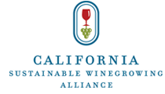

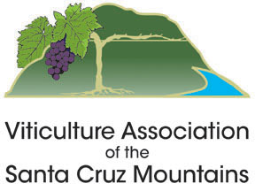

Santa Cruz Mountains Climate Action Workshop

March 18, 2026
Ridge Vineyards – Monte Bello
17100 Montebello Road, Cupertino 95014
1pm-4pm
Agenda:

1:00 pm Welcome and Introductions

1:10 pm Climate Change Impacts and Actionable Strategies for Adaptation and Mitigation
Lisa Francioni, Deputy Director, California Sustainable Winegrowing Alliance
Key research findings on climate change impacts for California viticulture will be shared, along with an overview of climate action concepts and an introduction to a new Climate Action Toolkit that helps prioritize resilient vineyard practices for adaptation and mitigation.

1:40 pm Mitigating and Adapting to Climate Change through Soil Health
Dana Revallo, Head of Customer Success, Agrology
Background on the importance of building soil microbial function as a tool for mitigating and adapting to climate change will be shared, along with the findings from a pilot project with Redwood Empire Vineyard Management and Sonoma County Winegrowers.

2:20 pm Break

2:35 pm Using Dry Farming Techniques for Climate Resilience
Lauren Pesch, Dry Farmer, Consultant and CSWA Dry Farm Project Manager
Reduced water availability will be one of the most significant climate change challenges faced by California vineyards. While dry farming (not using irrigation after the vines are established) is not suitable for every vineyard in California, there are specific techniques used in many dry farmed vineyards that can also be implemented in irrigated vineyards to help reduce water demand and irrigation needs. This discussion will provide background on dry farming and cover practices that can help vineyards become more drought resilient. Recent research results on dry farming practices and soil health will also be shared.

3:15 pm Climate Action at Ridge Vineyards
David Gates, Senior VP of Vineyard Operations, Ridge Vineyards
Highlights from decades of sustainability initiatives will be shared through the lens of climate action. Climate smart practices that help mitigate and adapt to climate change, such as soil health, water security and savings; and in the winery: energy efficiency, renewable energy and packaging, will be discussed. Ridge’s participation in the International Wineries for Climate Action and their learnings from conducing greenhouse gas emissions audits will also be shared.

3:55 pm Wrap-up

4:00 pm Wine Reception

