Last Update: May 6, 2023
Cave Gulch Wine Coop: Wine Making Equipment For-Sale List

Location: Santa Cruz County near UCSC – Exact location will be provided to interested buyers.
Appointments: Readily available and required in advance of inspection, payment, and pickup.
Contacts: Please reach out to Matthew and Ralph and give them a day to get back to you. We’ll get back to you in one day of receiving your call or text to answer any questions, set up an appointment, etc. If you do not hear back from either of us within 24 hours, please contact Susan or Robin and they’ll be sure to set something up.
- Primary:
  - Matthew Coale: Cell (831) 750-5279
  - Ralph Maltese: Cell (831) 334-5092
- Secondary:
  - Susan Coale: (831) 750-7580
  - Robin Rainwater: (831) 818-2883
Terms:
- As Is: No returns, no refunds, no warranties. All equipment can be inspected and tested on site; Friendly people familiar with each piece of equipment are available to assist with your inspection.
- Multiple Item Purchase Discounts are available.
- Cash payment. Local Santa Cruz vineyards, wineries and wine coops may pay by check. Checks to be made payable to Susan Coale.
- Payment is required prior to receiving equipment. Full advanced payment is required to hold equipment prior to being picked up. All equipment must be picked up within two weeks of purchase.
- Delivery: Pickup is preferred and may be required for larger items. Local Santa Cruz Delivery may be available for some items but may not be available.
- Two (2) ton Enoitalia Crusher/Destemmer. Asking Price: $1,600
  - Includes 2 hp 230v single phase crushing/destemming motor and integrated belt-driven must pump. Additional items:, extra replacement drive belts, tri clover stainless steel fittings and clamps, grape must hose used to pump to primary fermentation bins. Mounted on casters.
  - Condition: Good working order. All parts in excellent working condition. Missing one rubber crushing roller spindle that is sometimes desired when processing white wine grapes. The spindle is not needed when crushing red grapes (as configured this unit is equivalent to an EnoItalia Jolly 25 Destemmer. Another roller can be purchased for $100 - $150.)
  - 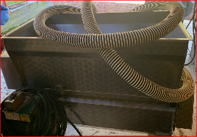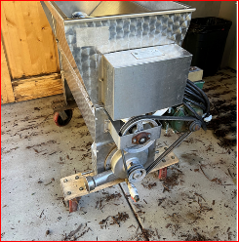

- GAI all Stainless Steel 8-Bottle Siphon Bottle Filler. Asking Price: $3450
  - Condition: Perfect – used once. This filler cost us $4088.00 plus delivery for a total of $4300.
  - 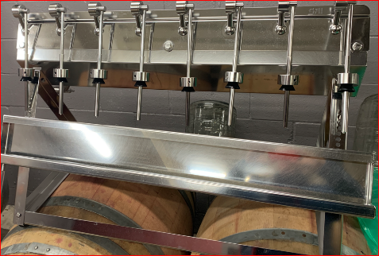
Other items for sale:
Description | Quantity Available | Price (each)
American Oak Barrels – reconditioned – single use | 8 | $100
Glass carboys (3, 5 and 6 gallons) | 36 | $20
Barrel Racks – 2 barrels | 9 | $30
8 Wine Bottle washer/rinser | 1 | $30
55 gallon plastic barrels | 2 | $15
Miscellaneous yeast, bungs, corks, oak chips, airlocks, etc. | Inquire | Any reasonable offer
Used Multiple Season Neutral French and American Oak Barrels | Inquire | Any reasonable offer

